**Github process**

**Step 1:create a repo**

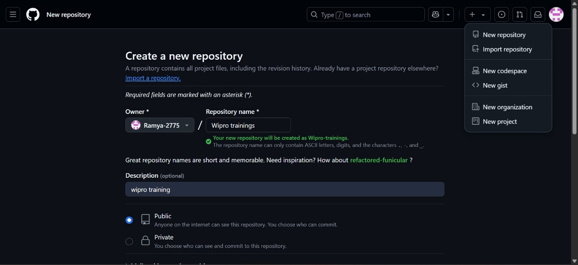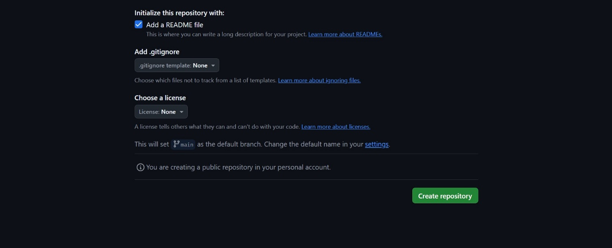

**Step 2:copy the link**

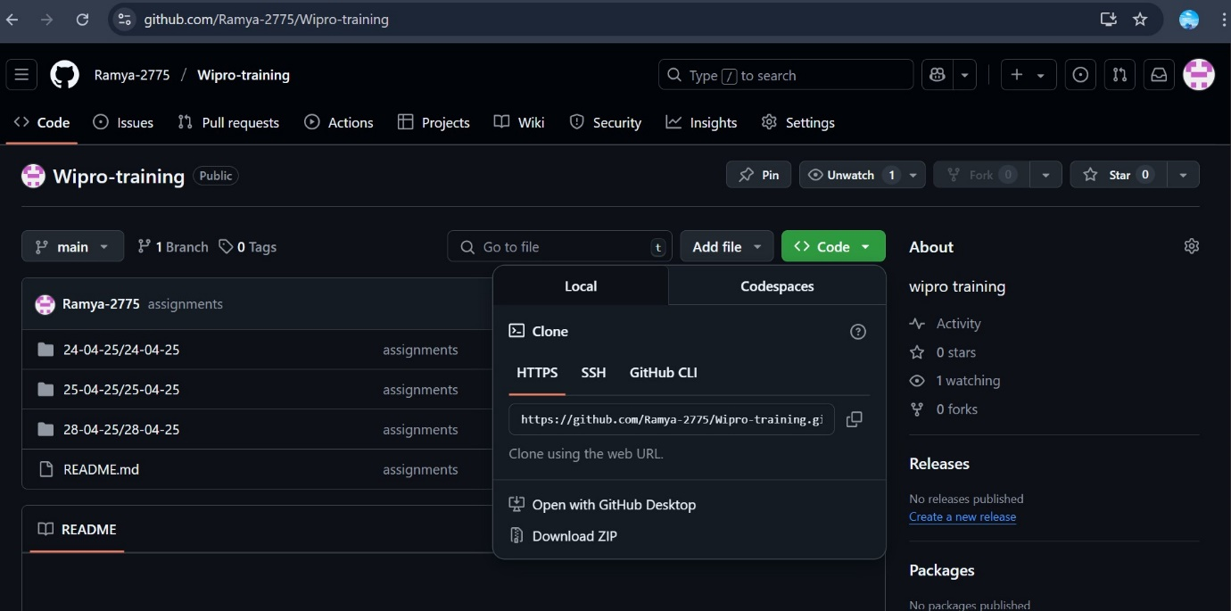

**Step 3:clone the link in vs code using the command git clone**

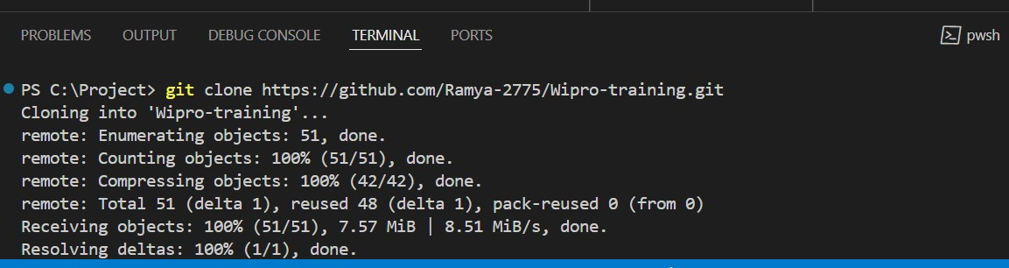

**Step 4:upload the project folders**

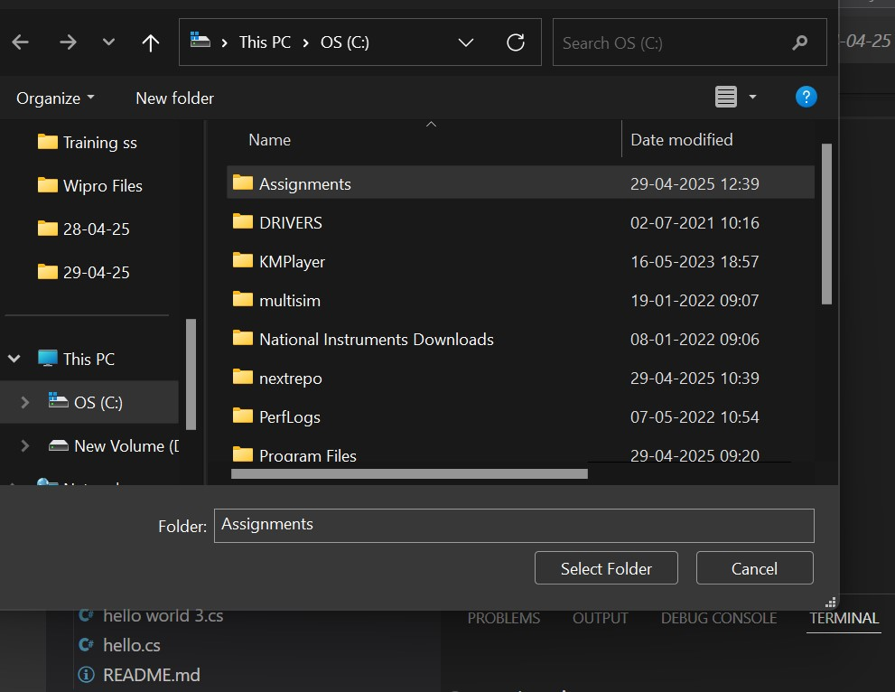

**Step 5:commit and push**

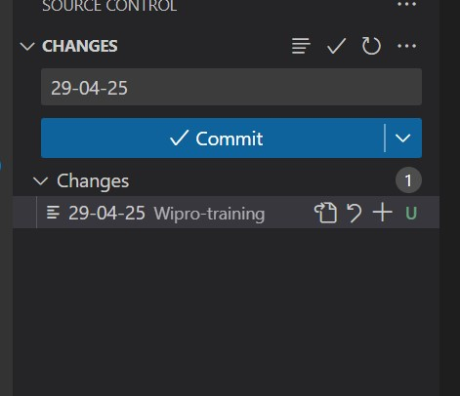

**Step 6:chek the github and its uploaded**

